**ARRAYS**

**LAB # 8**



**Spring 2019**

**CSE102L Computer Programming Lab**

Submitted by: **Shah Raza**

Registration No. : **18PWCSE1658**

Class Section: **B**

“On my honor, as student of University of Engineering and Technology, I have neither given nor received unauthorized assistance on this academic work.”

Student Signature: ______________

Submitted to:

**Engr. Madiha Sher**

March 8,2019

Department of Computer Systems Engineering

University of Engineering and Technology, Peshawar

**TASK #1:**

Write a program that initializes a string and finds how many times a substring (entered by user) appears in it. The size of substring must be less than or equal to the size of string.

**Code:**

#include <iostream>

#include <stdio.h>

#define SIZE 20

using namespace std;

int main()

{

char A1[SIZE],A2[SIZE];

cout<<"Enter a string: ";

gets(A1);

cout<<"Enter a sub string: ";

gets(A2);

int i=0,b=0,counter=0;

for (;A1[i]!='\0';i++); //String length of A1

for (;A2[b]!='\0';b++); //String length of A2

for(int a=0;a<i;a++)

{

int c=0;

for(;c<b;c++)

{

if (A1[a+c]!=A2[c])

break;

}

if (c==b)

counter++;

}

cout<<"The sub string appeared "<<counter<<" times in the main string";

return 0;

}

**Output (Compilation, Testing and Debugging):**

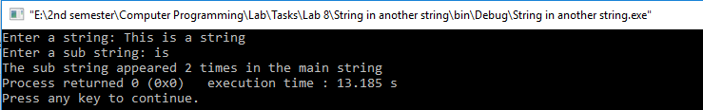

**TASK #2:**

Take a set of N students’ examination marks (in the range 0 to 100) as input, Formulate a program that makes a count of the number of students that passed and failed the examination separately. A pass is awarded for all marks of 50 and above. Also display the minimum, maximum and average score.

**Code:**

#include <iostream>

using namespace std;

int main()

{

const int SIZE=5;

int Marks[SIZE],pass=0,fail=0;

float Avg,sum=0;

cout<<"Enter an Array: \n";

for(int i=0;i<SIZE;i++) //Input string

{

cin>>Marks[i];

}

int Min=Marks[0],Max=Marks[0];

for (int i=0;i<SIZE;i++) //Min Max

{

if(Marks[i]>Max)

Max=Marks[i];

if (Marks[i]<Min)

Min=Marks[i];

}

for (int i=0;i<SIZE;i++) //Pass Fail

{

if(Marks[i]>=50)

pass++;

else

fail++;

}

for (int i=0;i<SIZE;i++) //sum

{

sum=sum+Marks[i];

}

Avg=sum/SIZE;

cout<<"Min: "<<Min;

cout<<"\nMax: "<<Max;

cout<<"\nPass: "<<pass;

cout<<"\nFail: "<<fail;

cout<<"\n Average: "<<Avg;

return 0;

}

**Output (Compilation, Testing and Debugging):**

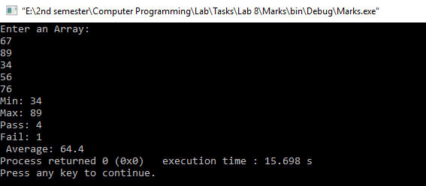

**TASK #3: PART A:**

Write a program that uses functions to perform the following operations:

1. Insert sub-string into main string from given position.

**Code:**

#include <iostream>

#include <stdio.h>

using namespace std;

int main()

{

const int SIZE=20;

char A1[SIZE],A2[SIZE];

int pos;

cout<<"Enter First string: ";

gets(A1);

cout<<"Enter second string: ";

gets(A2);

cout<<"Enter the position where item has to be inserted: ";

cin>>pos;

int i=0,b=0;

for(;A1[i]!='\0';i++); //String length of A1

for (;A2[b]!='\0';b++); //String length of A2

for(int a=i-1,c=0;c<i-b;a--,c++) // Shifting

{

A1[a+b]=A1[a];

}

A1[i+b]='\0';

for (int a=pos,c=0;c<b;a++,c++) // Inserting

{

A1[a]=A2[c];

}

cout<<A1;

return 0;

}

**Output (Compilation, Testing and Debugging):**

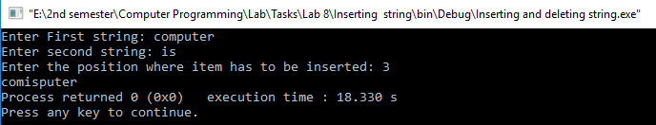

**PART B:**

Delete n Characters from a given position in given string.

**Code:**

#include <iostream>

#include <stdio.h>

using namespace std;

int main()

{

const int SIZE=20;

char A[SIZE];

int pos,n;

cout<<"Enter the string: ";

gets(A);

cout<<"Enter position: ";

cin>>pos;

cout<<"Enter the no of characters you want to delete: ";

cin>>n;

int i=0;

for(;A[i]!='\0';i++); //String length of A

for(int a=pos-n,c=0;c<i-pos;a++,c++) //Deleting process

{

A[a]=A[pos+c];

}

A[i-n]='\0';

cout<<A;

return 0;

}

**Output (Compilation, Testing and Debugging):**

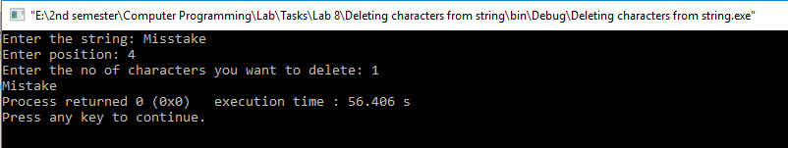

**TASK #4:**

Write a program that takes two arrays as input and find the sum of all the elements of both the arrays and displays which array has the higher sum value.

**Code:**

#include <iostream>

using namespace std;

int main()

{

const int SIZE=5;

int A1[SIZE],A2[SIZE],sum1=0,sum2=0;

cout<<"Enter A1:";

for(int i=0;i<SIZE;i++) //Input A1

{

cin>>A1[i];

}

cout<<"Enter A2:";

for(int i=0;i<SIZE;i++) //Input A2

{

cin>>A2[i];

}

for(int i=0;i<SIZE;i++) //Finding sums

{

sum1+=A1[i];

sum2+=A2[i];

}

cout<<"Sum1= "<<sum1;

cout<<"\nSum2= "<<sum2<<endl;

if(sum1>sum2)

cout<<"A1 has higher sum";

else if(sum1<sum2)

cout<<"A2 has higher sum";

else

cout<<"A1 and A2 have equal sums";

return 0;

}

**Output (Compilation, Testing and Debugging):**

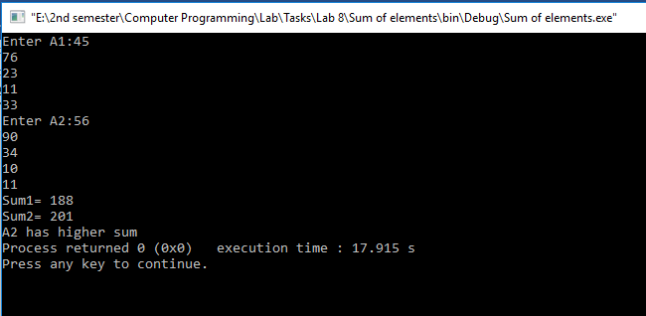

**TASK #5:**

Write a program that takes a string as input. If the character is upper case convert it into lower case and if the character is lower case then convert it in to upper case.

**Code:**

#include <iostream>

#include <stdio.h>

using namespace std;

int main()

{

const int SIZE=20;

char A[SIZE];

gets(A);

int i=0;

for (;A[i]!='\0';i++); //String length of A

for(int a=0;a<i;a++) //Conversion of Cases

{

if(A[a]>='a'&&A[a]<='z')

A[a]=A[a]-32;

else if(A[a]>='A' && A[a]<='Z')

A[a]=A[a]+32;

}

for(int a=0;a<i;a++) //Display A

cout<<A[a];

return 0;

}

**Output (Compilation, Testing and Debugging):**

